JavaDoc = in TestGradesGUI/doc

UML Class Diagram



UML Class Diagram (Object-Aid)

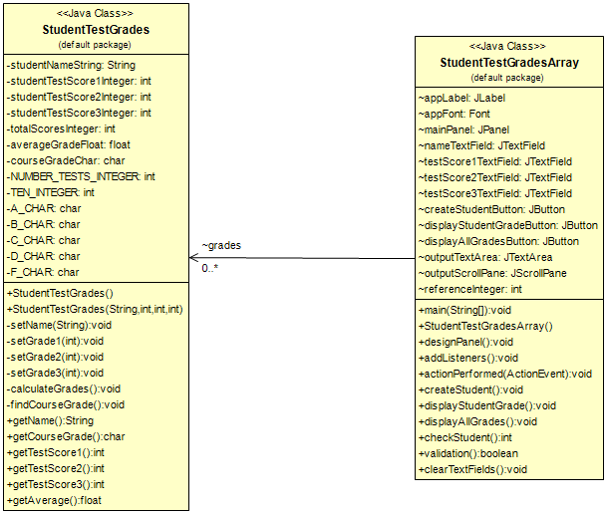

USE CASE DIAGRAM



FLOW CHART



WIREFRAME



UI

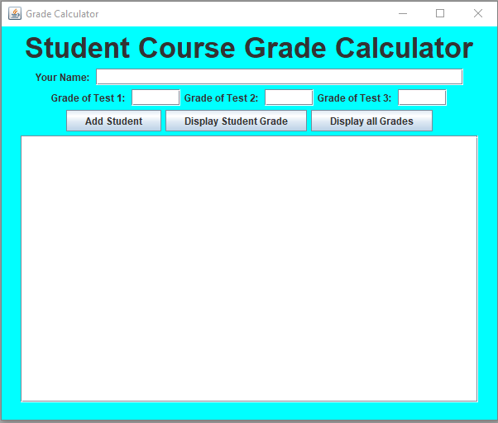

Prototype (double click on image below)

